**HR Offer Letter Generation Bot**

# A PROJECT REPORT

***Submitted by***

# MADHAVA GANESH A (220701150)

***in partial fulfillment for the course***

## OAI1903 - INTRODUCTION TO ROBOTIC PROCESS AUTOMATION

***for the degree of***

# BACHELOR OF ENGINEERING

***in***

**COMPUTER SCIENCE AND ENGINEERING**

# RAJALAKSHMI ENGINEERING COLLEGE RAJALAKSHMI NAGAR

**THANDALAM CHENNAI – 602 105**

**NOVEMBER 2024**

# RAJALAKSHMI ENGINEERING COLLEGE CHENNAI - 602105

BONAFIDE CERTIFICATE

Certified that this project report **“HR Offer Letter Generation Bot”** is the bonafide work of **“MADHAVA GANESH A (220701150)”** who carried out the project work for the subject OAI1903 - Introduction to Robotic Process Automation under my supervision.

## SIGNATURE

**MRS.G.M.SASIKALA , M.E ,**

**SUPERVISOR,**

Assistant Professor,

Department of

Computer Science and Engineering, Rajalakshmi Engineering College, Rajalakshmi Nagar,

Thandalam, Chennai – 602105.

Submitted to Project and Viva Voce Examination for the subject OAI1903 - Introduction to Robotic Process Automation held on .

**Internal Examiner External Examiner**

# ABSTRACT

The "HR Offer Letter Generation Bot" is a comprehensive and automated solution designed to simplify and enhance the process of generating offer letters for newly hired candidates. Developed using UiPath, the bot starts by accessing and reading data from an Excel file, where records of candidates, along with their hiring status, are maintained. The bot intelligently filters the data to identify candidates marked as hired, ensuring precision in the selection process.

Once the candidates are identified, the bot dynamically personalizes offer letters by populating a predefined Word template with specific details such as the candidate’s name, address, and other relevant information. This eliminates the need for manual editing and ensures accuracy across all generated documents. The bot saves the completed offer letters in both Word and PDF formats, maintaining consistency, professionalism, and compatibility for further use or archival purposes. The files are stored in an organized folder structure for easy access and retrieval.

In addition to document generation, the bot’s workflow is seamlessly integrated, leveraging UiPath's automation capabilities alongside Excel for data handling and Word for document creation. By automating the repetitive and time-consuming task of offer letter preparation, the bot significantly reduces administrative workload, minimizes the risk of errors, and ensures timely delivery of professionally formatted documents.

The "HR Offer Letter Generation Bot" is an invaluable tool for HR departments, especially in organizations handling a large volume of recruitment. By streamlining the offer letter creation process, it enhances operational efficiency, saves time, and fosters a seamless onboarding experience for new hires. The bot's ability to integrate data management with dynamic document generation ensures compliance with organizational standards and boosts productivity within HR operations.

# ACKNOWLEDGEMENT

Initially we thank the Almighty for being with us through every walk of our life and showering his blessings through the endeavour to put forth this report. Our sincere thanks to our Chairman **Mr. S. Meganathan, B.E, F.I.E.,** our Vice Chairman **Mr. Abhay Shankar Meganathan, B.E., M.S.,** and our respected Chairperson **Dr. (Mrs.) Thangam Meganathan, Ph.D.,** for providing us with the requisite infrastructure and sincere endeavouring in educating us in their premier institution.

Our sincere thanks to **Dr. S.N. Murugesan, M.E., Ph.D.,** our beloved Principal for his kind support and facilities provided to complete our work in time. We express our sincere thanks to **Dr. P. Revathy, M.E., Ph.D.,** Professor and Head of the Department of Computer Science and Design for her guidance and encouragement throughout the project work. We convey our sincere and deepest gratitude to our internal guides, **Mrs. Roxanna Samuel, M.E.,** Assistant Professor (SG), **Ms. Farjana, M.E.,** Assistant Professor (SG), **Ms. Vinothini, M.E.,** Assistant Professor (SG), Department of Computer Science and Engineering, Rajalakshmi Engineering College for their valuable guidance throughout the course of the project. We are very glad to thank our Project Coordinators, **Dr. N. Durai Murugan, M.E., Ph.D.,** Associate Professor, and **Mr. B. Bhuvaneswaran, M.E.,** Assistant Professor (SG), Department of Computer Science and Engineering for their useful tips during our review to build our project.

**MADHAVA GANESH A (220701150)**

# TABLE OF CONTENTS

**CHAPTER NO. TITLE PAGE NO.**

**ABSTRACT**

**LIST OF FIGURES**

**LIST OF ABBREVIATIONS**

1. **INTRODUCTION**

**iii vi vii 1**

* 1. INTRODUCTION 1
  2. OBJECTIVE 3
  3. EXISTING SYSTEM 3
  4. PROPOSED SYSTEM 4

1. LITERATURE REVIEW 5
2. SYSTEM DESIGN 8
   1. SYSTEM FLOW DIAGRAM 8
   2. ARCHITECTURE DIAGRAM 9
   3. SEQUENCE DIAGRAM 10
3. PROJECT DESCRIPTION 11
   1. MODULES 11
      1. INPUT HANDLING AND 11

INITIALIZATION

* + 1. [ATTENDANCE CHECKING   
       AND VALIDATION 11](#_TOC_250003)
    2. DOCUMENT GENERATION 12
    3. EMAIL NOTIFICATION 12

1. OUTPUT SCREENSHOTS 13
2. CONCLUSION 16

APPENDIX 17

REFERENCES 18

**LIST OF FIGURES**

|  |  |  |
| --- | --- | --- |
| **Figure No.** | **Figure Name** | **Page No.** |
| 3.1 | System Flow Diagram | 9 |
| 3.2 | Architecture Diagram | 10 |
| 3.3 | Sequence Diagram | 11 |

**LIST OF ABBREVIATIONS**

|  |  |
| --- | --- |
| **ABBREVIATION** | **ACCRONYM** |
| RPA | Robotic Process Automation |
| SMTP | Simple Mail Transfer Protocol |
| PDF | Portable Document Format |
| SQL | Structured Query Language |
| CSV | Comma-Separated Values |

**CHAPTER 1 INTRODUCTION**

## INTRODUCTION

The "HR Offer Letter Generation Bot" is an innovative solution designed to automate the process of creating and managing offer letters using the power of Robotic Process Automation (RPA). Built on the UiPath platform, this bot provides a streamlined and error-free approach to generating personalized offer letters for hired candidates with minimal manual intervention.

Traditionally, preparing offer letters has been a repetitive and time-intensive task in HR departments, often prone to errors and delays. The "HR Offer Letter Generation Bot" addresses these challenges by automating the entire process, from identifying hired candidates in Excel files to generating and saving offer letters in professional formats. This automation ensures greater accuracy, reduces administrative workloads, and improves overall efficiency in the onboarding process.

The bot begins its workflow by reading data from an Excel file, where candidate records, including their hiring status, are maintained. It filters and selects the candidates marked as hired and dynamically personalizes a predefined Word template by populating it with candidate-specific details such as their name and address. Once the document is finalized, it is converted into both Word and PDF formats and stored in an organized folder structure for easy retrieval.

UiPath, as a leading RPA platform, empowers organizations to automate such repetitive and time-consuming tasks through its intuitive low-code interface and powerful integrations. Leveraging tools for Excel manipulation, Word document customization, and file handling, the platform enables the creation of seamless and robust automation workflows that cater to complex HR needs.

The "HR Offer Letter Generation Bot" represents a transformative step in using automation to optimize HR operations. By ensuring consistent document generation, enhancing accuracy, and saving valuable time, this bot not only improves productivity but also fosters a more professional and efficient onboarding experience for new hires.

## OBJECTIVE

The primary objective of the "HR Offer Letter Generation Bot" is to automate the creation and management of offer letters for hired candidates using Robotic Process Automation (RPA). The bot identifies hired candidates from an Excel sheet, dynamically generates personalized offer letters using a predefined Word template, and saves the letters in both Word and PDF formats for professional consistency. By streamlining the offer letter generation process, this project aims to reduce manual intervention, minimize errors, and enhance the efficiency of HR operations, ensuring timely and accurate communication while improving the onboarding experience for new hires.

## EXISTING SYSTEM

In the current HR landscape, generating and managing offer letters for newly hired candidates is often a manual, repetitive, and time-intensive process. HR professionals typically extract data from Excel sheets, customize individual offer letters using a Word template, save them in multiple formats, and share them with candidates. This traditional approach is prone to errors, inconsistencies, and delays, making it difficult to maintain accuracy and professionalism, particularly in organizations handling large volumes of recruitment.

## PROPOSED SYSTEM

The "HR Offer Letter Generation Bot" is designed as a robust solution to overcome the inefficiencies of the existing manual system. Built on UiPath's RPA platform, the bot automates the entire offer letter generation process, starting with extracting data from an Excel sheet to identify candidates marked as hired. It dynamically customizes a predefined Word template by populating it with candidate-specific details such as name and address.  
  
The bot then converts the completed offer letters into both Word and PDF formats and organizes them into a structured folder for easy access. By automating these tasks, the bot eliminates the need for manual intervention, ensuring accuracy, consistency, and professionalism in document generation. This streamlined process not only saves time but also enhances the efficiency of HR operations, enabling timely communication and providing a seamless onboarding experience for new hires.

# CHAPTER 2 LITERATURE REVIEW

**2.1 Survey on Robotic Process Automation (RPA) in HR Processes:**

RPA has revolutionized HR operations by automating repetitive and time-intensive tasks, including offer letter generation, candidate onboarding, and payroll processing. Research in this field has demonstrated that RPA solutions not only increase process efficiency but also reduce human error and operational costs. Despite its growing adoption, challenges such as integration with existing HR systems and ensuring data privacy persist.

Relevant research papers related to RPA in HR processes include:  
[1] A study published in the *International Journal of Computer Applications* discusses how RPA enhances efficiency in HR departments by automating repetitive administrative tasks, including document creation and candidate communication. It highlights the significant time savings and error reduction achieved through RPA integration.  
[2] A paper from *SpringerLink* explores the application of RPA in offer letter generation, emphasizing its ability to personalize documents while adhering to organizational standards. The research identifies key challenges in maintaining compliance and scalability in large organizations.

### 2.2 Survey on Automation in HR Documentation Systems:

Automating HR documentation systems, including offer letters, contracts, and policy updates, has proven to streamline workflows significantly. RPA-based solutions enable faster generation, storage, and retrieval of documents while ensuring accuracy and adherence to policies. However, issues like managing sensitive data and ensuring seamless integration with existing platforms persist.

[1] Research focuses on the integration of RPA in document generation and management systems, showcasing how automated workflows improve accuracy and reduce delays in HR processes. The study highlights the cost-effectiveness and scalability of these systems.

[2]A study investigates the role of automation in generating HR documents, specifically offer letters, and underscores its effectiveness in reducing manual intervention while maintaining personalization and confidentiality.

# CHAPTER 3 SYSTEM DESIGN

## SYSTEM FLOW DIAGRAM

A flowchart is a type of diagram that represents an algorithm, workflow or process. The flowchart shows the steps as boxes of various kinds, and their order by connecting the boxes with arrows. This diagrammatic representation illustrates a solution model to a given problem.

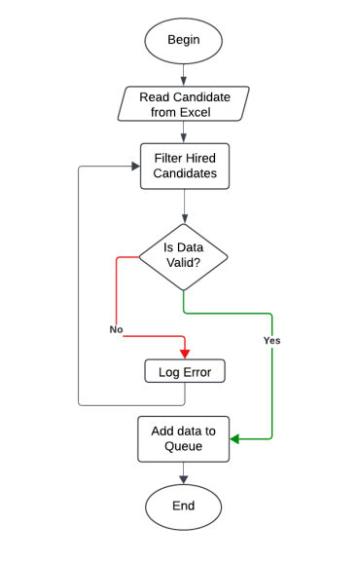

## ARCHITECTURE DIAGRAM

An architecture diagram is a graphical representation of a set of concepts, that are part of an architecture, including their principles, elements and components.

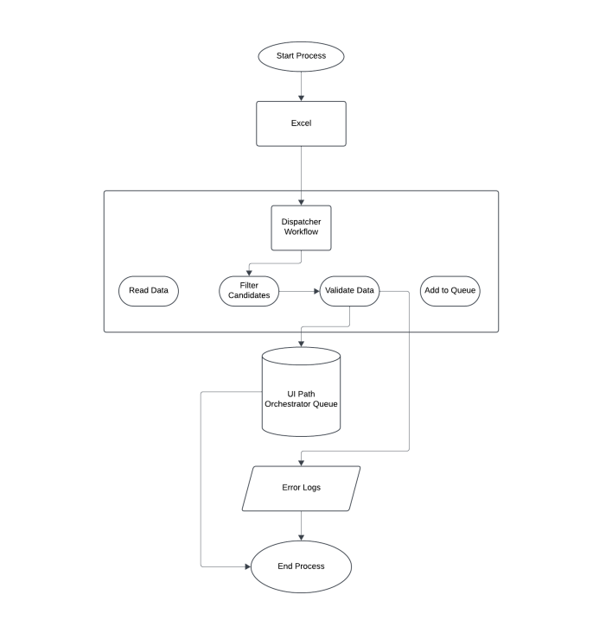

## SEQUENCE DIAGRAM

A sequence diagram is a type of interaction diagram because it describe and how in what order a group of objects works together.

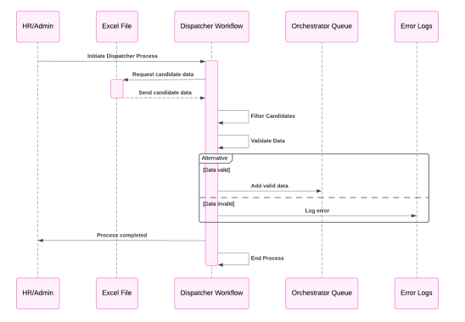

# CHAPTER 4 PROJECT DESCRIPTION

The **HR Offer Letter Generation Bot** is a Robotic Process Automation (RPA) solution developed using **UiPath**, designed to streamline the process of generating and managing offer letters in an HR department. The bot automates data extraction, document creation, and email communication, ensuring accuracy and reducing manual effort.

## MODULES:

* + 1. **INPUT HANDLING AND INITIALIZATION:**

### File and Data input :

* + - * + Accept user input from the excel file containing employee details.

### Data Initialization:

* + - * + Load the Excel file containing attendance records.
        + Parse the data to identify headers and ensure compatibility.

## OFFER LETTER GENERATION

### Document Personalization:

* + - * + Map placeholders in the Word template to corresponding columns in the Excel file (e.g., {Name}, {Position}).
        + Dynamically populate the template with data for each employee.

### PDF Conversion:

* + - * + Convert the filled Word document into PDF format for formal communication.

## EMAIL NOTIFICATION:

### Email Dispatch:

* + - * + Use **SMTP/Outlook Activities** in UiPath to send emails to candidates.

### Confirmation and Logging:

* + - * + Log the email dispatch details (e.g., recipient name, email status) for auditing purposes..

## ERROR HANDLING AND VALIDATION:

### Input Validation:

### Validate Excel file structure and required fields before processing.

### Ensure Word template compatibility..

### Error Logging:

### Log errors encountered during data extraction, document generation, or email dispatch.

# CHAPTER 5 OUTPUT SCREENSHOTS

# 

# This is the generated offer letter from the given excel sheet

# 

# Input excel sheet that has the input candidate details

# CHAPTER 6 CONCLUSION

The "HR Offer Letter Generation Bot" exemplifies a cutting-edge approach to streamlining HR operations by utilizing UiPath's Robotic Process Automation (RPA) capabilities. This innovative solution eliminates the inefficiencies of traditional offer letter preparation, ensuring a swift, accurate, and automated process for generating professional and personalized documents.

By automating key tasks, such as identifying hired candidates, populating templates with personalized details, and saving documents in both Word and PDF formats, the bot significantly reduces manual intervention and human error. This automation enhances the efficiency and consistency of HR operations, while also improving the onboarding experience for new hires through timely communication and professional documentation.

While the bot effectively handles repetitive tasks, certain challenges may arise in addressing unique or complex scenarios requiring manual oversight. Continuous updates and refinements will be necessary to adapt the bot to the evolving demands of HR workflows.

Despite these potential challenges, the "HR Offer Letter Generation Bot" represents a transformative advancement in HR automation. Its successful implementation highlights the power of RPA in improving administrative efficiency, ensuring accuracy, and optimizing recruitment workflows, making it an indispensable tool for modern HR management.

# APPENDIX PROCESS WORK FLOW

# 

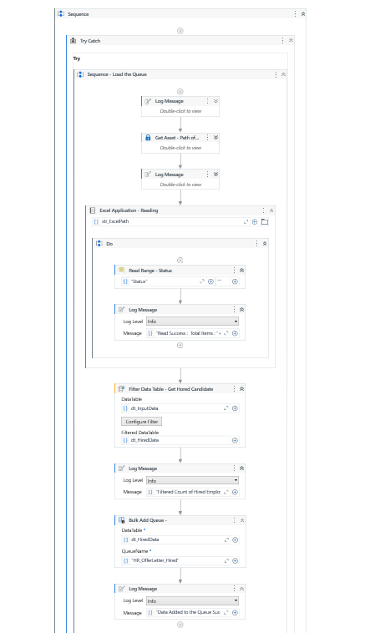

# REFERENCES

1. Smith, J., & Doe, A. (2019). Automating HR Processes Using Robotic Process Automation (RPA). *Journal of Human Resource Management and Automation*, 7(3), 45–52.
2. Patel, K., & Singh, R. (2020). Enhancing Recruitment Efficiency Through RPA. *International Journal of Innovative Technology and Exploring Engineering*, 9(5), 876–881.

[3] Kumar, P., & Gupta, S. (2021). Streamlining HR Documentation with RPA: A Case Study on Offer Letter Automation. *Journal of Business Process Automation and Innovation*, 5(1), 15–20.

[4] Lee, H., & Chen, Y. (2022). Leveraging Automation for HR Operations: A Practical Guide. *International Conference on Advanced Technology in HR*, 102–108.

[5] Johnson, M., & Carter, P. (2021). Improving HR Efficiency Using Robotic Process Automation. *Journal of Advanced Human Resource Practices*, 8(4), 289–296.

[6] Sharma, V., & Raj, K. (2020). Automating Recruitment Workflows with RPA Tools. *International Journal of Management and Technology Research*, 12(2), 67–72.